Importing and Running a Query Builder in My Practice

To Import a Query:

- Save the attached Query builder to your desktop or in your documents
- Open My Practice
- Go to Tools > Reports > Query Builder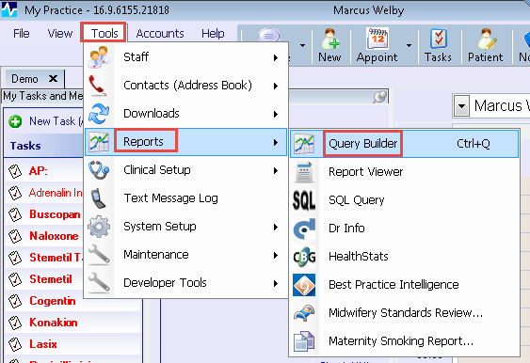
- Choose Import

- Now browse to your desktop or wherever you stored the Query Builder and open
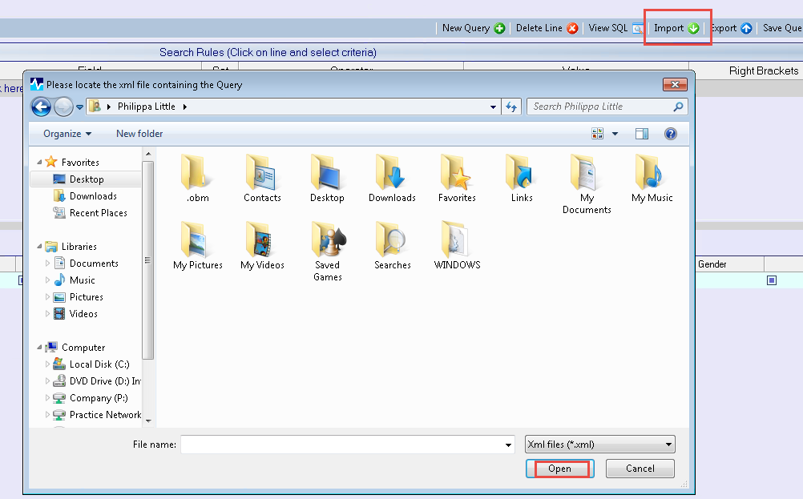

- Choose Search to Run the Query
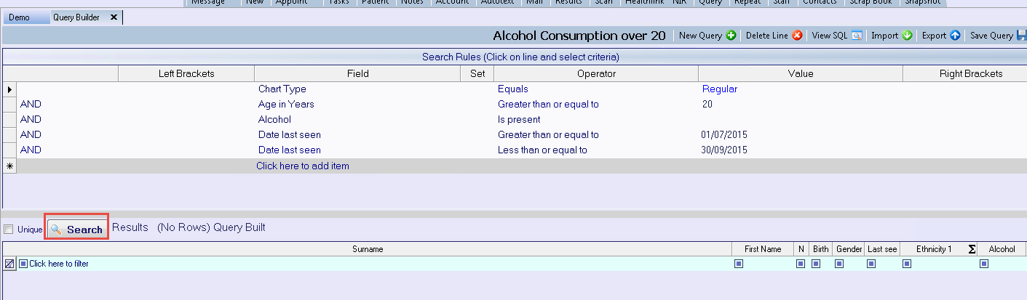

- Now Export the contents of the query so they can be reviewed in excel.
Choose Save As Excel File from the Actions Menu on the right hand side and save to disk.

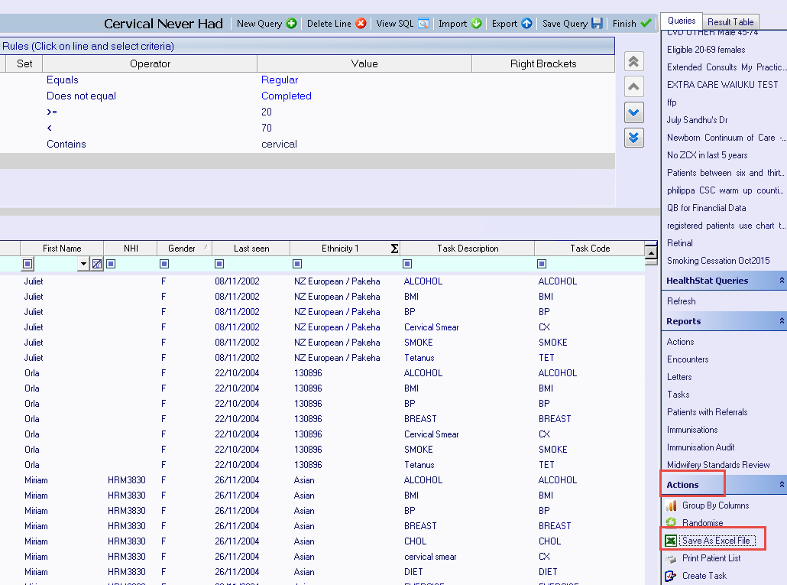

- Now go to where you saved the file and review or copy and paste to email to the PHO.
If you are sending the spreadsheet via EMAIL, Ensure you PASSWORD protect the email by encrypting it with a PASSWORD.

e.g. in Office 2010
1. Choose File
2. Choose Save As
3. Change the SAVE As TYPE File type to XLS or XLXs (CSV format won’t allow a password).
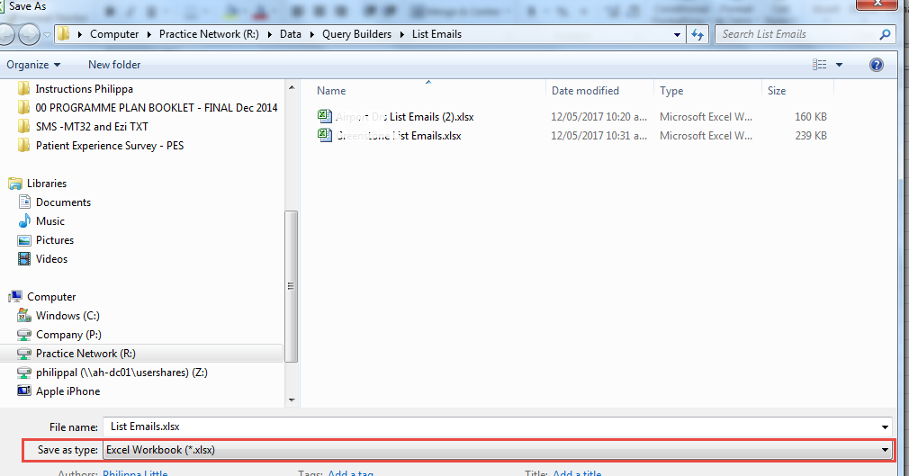

4. Choose File
5. Click Protect Workbook
6. Choose Encrypt with Password (use your Karo password Alnce_XXXX)
