**Importing and Running a Query Builder**

To import the query:

1. Save the attached Query builder to your desktop or in your documents
2. Open Medtech
3. Go to Tools > Query Builder
4. Double click Query Store
5. Right Click  a folder
6. Choose Import Query

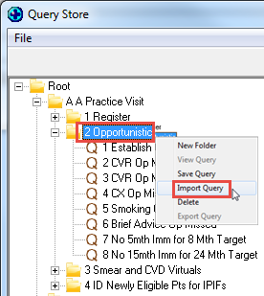

1. Now browse to your desktop or wherever you stored the Query Builder and open
2. Click on Run Query

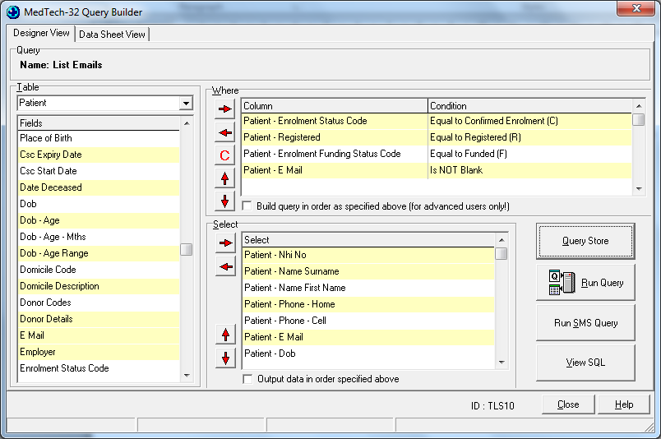

Now Export the contents of the query so they can be reviewed in excel.    Choose Export then Save to disk.

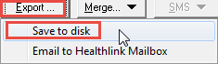

You will then be able to review the file

If you are sending the spreadsheet via EMAIL, Ensure you PASSWORD protect the email by encrypting it with a PASSWORD.

e.g. in Office 2010

1. Choose File

2. Choose Save As

3. Change the SAVE As TYPE File type to XLS or XLXs (CSV format won’t allow a password).

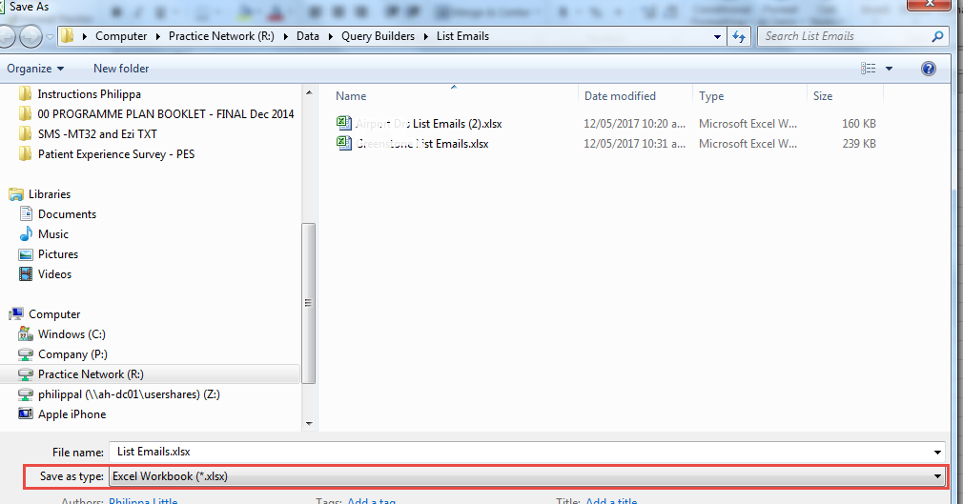

4. Choose File

5 . Click Protect Workbook

6. Choose Encrypt with Password (use your Karo password Alnce_XXXX)

